BUY A COW BINGO SQUARE TODAY!
$10 each
One ticket = one randomly assigned square.

Please mail cash or check to:
PO Box 170
Cochranville, PA 19330

Checks payable to: Canine Partners for Life
Reference: Cow Bingo

Name ___________________________________________________ # of tickets ___________
Address _________________________________________________________________________
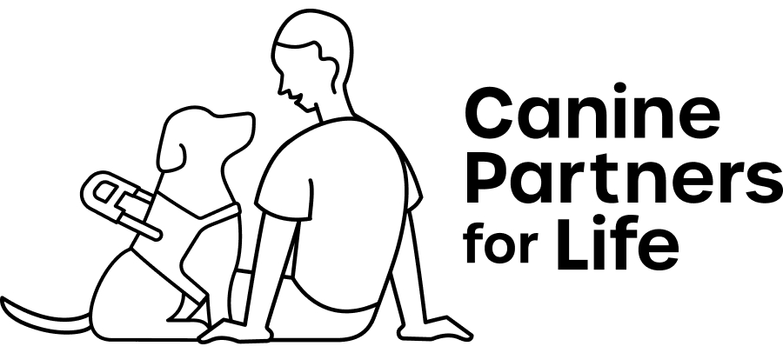
City ___________ State _________ Zip ___________
Phone __________________________________________
Email __________________________________________
Join us on Saturday, September 21st from 12-4 pm for CPL’s Fall Festival and Cow Bingo!
Date Received @ CPL __________________________

Orders will be processed on the day they are received and
ticket stubs will be mailed back to you. Tickets are not tax deductible.
SGOC #1726
Special Raffle Permit #219

